SCUBA-2 Block Specification
adc_sample_coadd

Table of Contents

1. Block Overview 3
1.1 Block Location and Block Interface within System 3
1.2 Block Functionality / Features 3
1.3 Block Dataflow 5
1.3.1 Top Level Dataflow 5
1.3.2 Raw Data Manager Dataflow 6
1.3.3 Co-add Data Manager Dataflow 6
1.3.4 Dynamic Data Manager Dataflow 6
2. Block Interfaces 7
2.1 Interface Signal Description 7
2.2 Interface Protocol and Timing 9
2.2.1 Input Signals 9
2.2.2 Raw Data Manager 9
2.2.3 wbs_frame_data Read Cycle 10
2.2.4 wbs_fb_data Read Cycle 10
2.2.5 Co-add Data Manager 10
2.2.6 Dynamic Data Manager 11
3. High-Level Description 12
3.1 State Machine Descriptions 12
3.1.1 Raw Data Manager 12
3.1.2 Co-add Data Manager 14
3.2 Special Optimizations 14
4. Files of the Block 15
4.1 Source Code 15
4.1.1 Source1.vhd 15
4.2 Header Code 15
4.2.1 Header1.vhd 15
5. Naming Conventions Used 16

Block Overview

Block Location and Block Interface within System
The adc_sample_coadd is a component in flux_loop_ctrl. The flux_loop_ctrl is instantiated eight times, one per channel, in the flux_loop block of a Readout Card.
As illustrated in Figure 1, the adc_sample_coadd interfaces with the following blocks:
- The ADC of the Readout card;
- The frame_timing block on the Readout card;
- The wbs_frame_data on the flux_loop block;
- The wbs_fb_data on the flux_loop block;
- The fsfb_calc in the flux_loop_ctrl.

ADC
wbs_frame_data
frame_timing
adc_sample_coadd
flux_loop_ctrl
fsfb_calc
wbs_fb_data
Figure 1: Location of adc_sample_coadd in the System.

Block Functionality / Features
In short, the adc_sample_coadd blobck samples the 14-bit parallel ADC (AD6644), inserts the raw data in raw_dat_bank, co-adds approximately 40 samples from each row to determine the next set of dynamic values to write to coadd_dat_bank0 or coadd_dat_bank1 and finds the current_difference and current_integral values. The current_coadd_value, current_difference, and current_integral are used for the next frame’s feedback calculation in the fsfb_calc.
A detailed list of tasks performed by the adc_sample_coadd is presented here.
- The adc_sample_coadd provides an encoding clock signal to ADC. In the present design, this clock is the same as the clk_50_i. The adc_sample_coadd assumes that a data is ready on each falling edge of the clock after the latency of the ADC. Moreover, no check is performed on the overflow flag from the ADC.
- On receiving a raw_req_i from wbs_frame_data, adc_sample_coadd saves the ADC values in a memory bank, raw_dat_bank, from the next restart_frame_aligned_i. These values are saved for a predetermined number of frames (currently we save two frames). On the completion of the raw data acquisition, raw_ack_o is asserted to indicate to wbs_frame_data that it can read the data independently from the raw_dat_bank. Note that raw_ack_o remains high until the raw_req_i is high.
- Independently to the raw data acquisition, per row, the data coming from ADC is co-added under the instruction of adc_coadd_en_i signal coming from frame_timing. The value read from the ADC is adjusted by the offset value read from wbs_fb_data for that row. Note that presently we do not latch the data from the wbs_fb_data. This is because it is assumed that the offset data is coming from a memory with registered outputs. At the end of the co-addition, the co-added value is saved in the current memory bank. The previous value of the co-added value for each row is, however, in the previous memory bank where the wbs_frame_data can independently read them. At the same time, the current_integral and current_difference values are calculated and current_integral is saved in the current memory bank. These values are calculated according to the following formulae:
current_value <= current_co_added_value
current_difference <= current_co_added_value – previous_value
current_integral <= previous_integral + current_co_added_value

- Finally, the current_value, current_difference, and current_integral are provided to the downstream block, fsfb_calc, and the coadd_done_o is asserted for one clock cycle after a predetermined delay after the end of a row time.

Block Dataflow

Top Level Dataflow
Figure 2 represents the dataflow for adc_sample_coadd. There are two independent data paths. The first one goes through the raw_data_manager and the second one goes through the coadd_data_manager and the dynamic_data_manager.

From ADC
raw_data_manager
raw_dat_bank
raw_req_i
To wbs_frame_dat
coadd_data_manager
current_bank
coadd_dat_bank0
coadd_dat_bank1
current_bank
integral_dat_bank1
itegral_dat_bank0
To wbs_frame_dat
current_bank
dynamic_data_manager
Current_difference
fsfb_calc
current_bank
F
F
F
F
From
wbs_fb_dat

Figure 2: adc_sample_coadd dataflow.

In the case of the raw_data_manager, the data from the ADC is stored in the raw_data_bank on the instruction from the raw_req_i signal.
In the case of the other data path, the adjusted ADC data (i.e., ADC data – offset from wbs_fb_data) is co-added and saved in the current bank of either coadd_dat_bank0 or coadd_dat_bank1. This current co-added value is available to the downstream block, i.e., fsfb_calc. In addition, the previous co-added data is available to the wbs_frame_data directly from the co-add data banks. Moreover, the current value of the co-add data from ADC and the previous co-add value from the co-add data bank are used to calculated the current integral in the dynamic_data_manager and is saved in the current integral_dat_bank0 or integral_dat_bank1. Simultaneously, the previous integral value is used in the dynamic_data_manager to calculate the current_difference. This difference value and the current integral value are also available to the downstream block, fsfb_calc.

Raw Data Manager Dataflow
The data from the ADC is directly fed into the raw_dat_bank.

Co-add Data Manager Dataflow
The dataflow for the co-add data manager is illustrated in Figure 3.
From ADC
+
-
From wbs_fb_data
F
F
To coadd_dat_bank0/1
Figure 3: Co-add Data Manager Dataflow.

Dynamic Data Manager Dataflow
The dynamic data manager dataflow is illustrated in Figure 4.

0
initialize_window_5dly
Current co-add value from
co-add data manager
+
0
current_bank
1
From
Integral_dat_bank1
From
Integral_dat_bank0
To
Integral_dat_bank0/1
F
F
F
F
0
initialize_window_5dly
+
0
current_bank
1
From
coadd_dat_bank1
From
coadd_dat_bank0
F
F
To
Downstream block
To
Downstream block
To
Downstream block
Figure 4: Dynamic Data Manager Dataflow.

Block Interfaces

Interface Signal Description

- Interface Signals
Signal | Description | Direction
Global
rst_i | Global reset | in
clk_50_i | Global clock | in
ADC Interface
adc_dat_i | Data from ADC | in
adc_ovr_i | Overflow flag from ADC | in
adc_rdy_i | Ready flag from ADC | in
adc_clk_o | Encoding clock to ADC | out
Frame_timing Interface
adc_coadd_en_i | Indicates the window to do co-addition | in
restart_frame_1row_prev_i | One-clock high signal at the boundary of last row in any frame. The falling edge corresponds to the beginning of row. | in
restart_frame_aligned_i | One-clock high signal at the boundary of first row in any frame. The falling edge corresponds to the beginning of row. | in
row_switch_i | One-clock high signal at the boundary of each row. The falling edge corresponds to the beginning of row. | in
initialize_window_i | This input is high for the entire duration of the first frame in any sequence of frames. | in
Wishbone Slave (wbs) Frame Data (wbs_frame_data) Interface
coadded_addr_i | Address index from wbs_frame-data for reading coadd value | in
coadded_dat_o | Co-add memory bank data output to wbs-frame_data | out
raw_addr_i | Address index from wbs frame data to read raw data | in
raw_dat_o | The raw_dat_bank output to wbs_frame_data | out
raw_req_i | Input from wbs_frame_data to ask for raw data. It is high until an acknowledge is issued by the raw_dat_manager_ctrl block. The adc_sample_coadd starts to acquire raw data from the first restart_frame_aligned_i after raw_req_i goes high. | in
raw_ack_o | Output to wbs_frame_data block to indicate the end of raw data acquisition. It remains high until it sees the falling edge of raw_req_i. | out
First Stage Feedback Calculation (fsfb_calc) Interface
coadd_done_o | It is asserted after certain delay after each row_switch_i, but only if adc_coadd_en_i is present in that row. | out
current_coadd_dat_o | Current co-added value. Valid from 5 clock cycles after the falling edge of adc_coadd_en_i to 5 clock cycles after the falling edge of the next adc_coadd_en_i. | out
current_diff_dat_o | Current difference value. Valid from 5 clock cycles after the falling edge of adc_coadd_en_i to 5 clock cycles after the falling edge of the next adc_coadd_en_i. | out
current_integral_dat_o | Current integral value. Valid from 5 clock cycles after the falling edge of adc_coadd_en_i to 5 clock cycles after the falling edge of the next adc_coadd_en_i. | out
Wishbone Slave Feedback Data (wbs_fb_data) Interface
adc_offset_dat_i | Offset value for each row used to adjust the ADC input | in
adc_offset_adr_o | This is the address index to retrieve the adc_offset_dat_i from the dedicated memory in wbs_fb_data. | out

Interface Protocol and Timing

Input Signals
Figure 5 illustrates the timing protocol for inputs signals from the frame timing block.
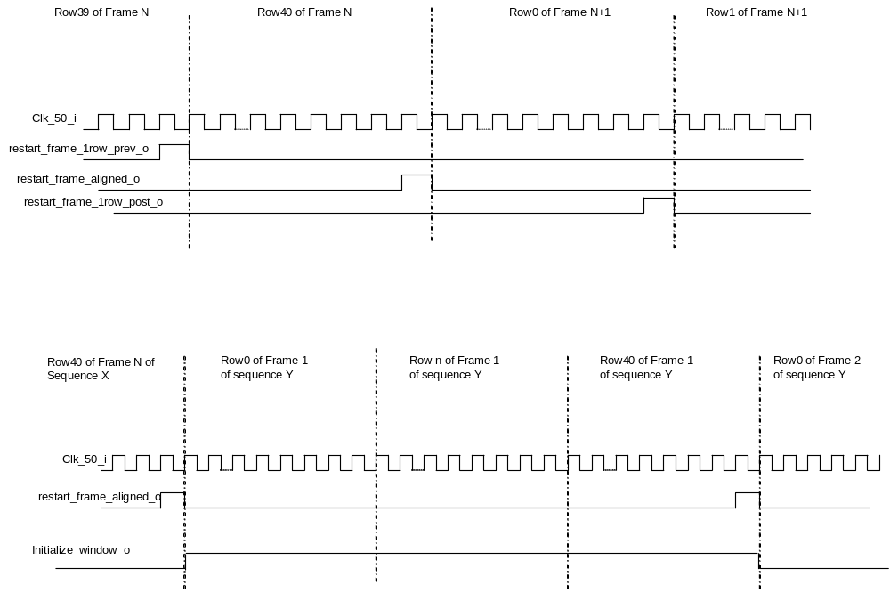
Figure 5: Timing for Input Signals.

Raw Data Manager
The protocol for the Raw Data Manager is as shown in Figure 6.

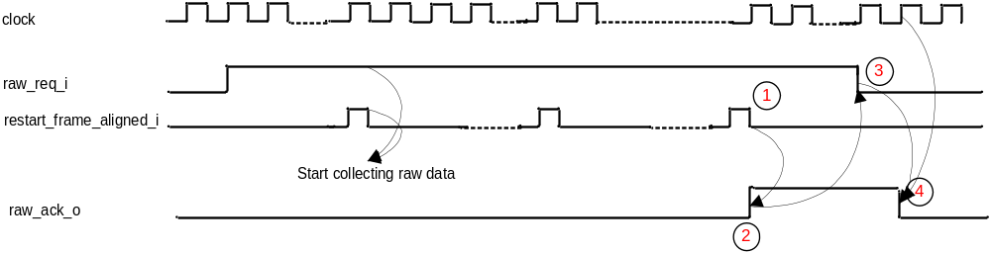
Figure 6: Raw Data Manager Timing Protocol.
After seeing a raw_req_i, we start collecting raw data on the falling edge of the first restart_frame_aligned_i signal. When the raw data collection is completed, we assert raw_ack_o high and keep it high until we see the falling edge of raw_req_i.

wbs_frame_data Read Cycle
All the memories in adc_sample_coadd block are registered at the inputs and the outputs. Therefore, a read cycle takes three clock cycles, as the data takes two clock cycles to be valid after a new address is asserted. The idea is shown in Figure 7.

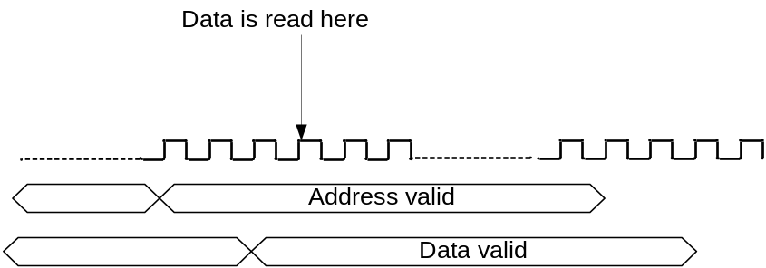
Figure 7: wbs_frame_data read cycle.

wbs_fb_data Read Cycle
Figure 8 illustrates the read cycle from wbs_fb_data. As seen in Figure 8, the address is valid on the 6th clock cycle after the falling edge of the adc_coadd_en_i and it is assumed that the data is valid after two clock cycles following the new address. However, this data is not used until the next adc_coadd_en_i signal where the offset values are taken away from the ADC input value in the co-add data manager.

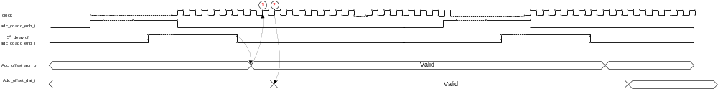
Figure 8: wbs_frame_data Read Cycle.

Co-add Data Manager
The timing protocol for the output of the co-add data manager is illustrated in Figure 9. As shown in Figure 9, the value for the current co-add is available to the wbs_frame_data after the first clock following the falling edge of the 5th delay of adc_coadd_enb_i signal. This latency is the result of the addition of the ADC latency and the required timing for writing the data in the co-add memory.

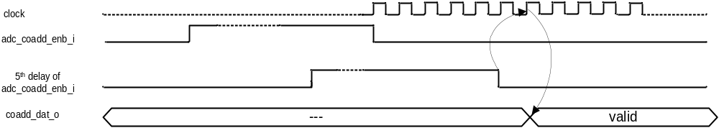
Figure 9: Co-add Data Manager Timing Protocol.

Dynamic Data Manager
The timing protocol for the output signals to the downstream block, fsfb_calc, is illustrated in Figure 10. The data buses are valid on the falling edge of the 5th delay element of the adc_coadd_enb_i signal. However, the coadd_done_o is only asserted after seeing the falling edge of the row_swith_i. The latency of coadd_done_o is parametrized in the coadd_dynamic_manager_ctrl.vhd and is currently six clock cycles after the falling edge of the row_swich_i.

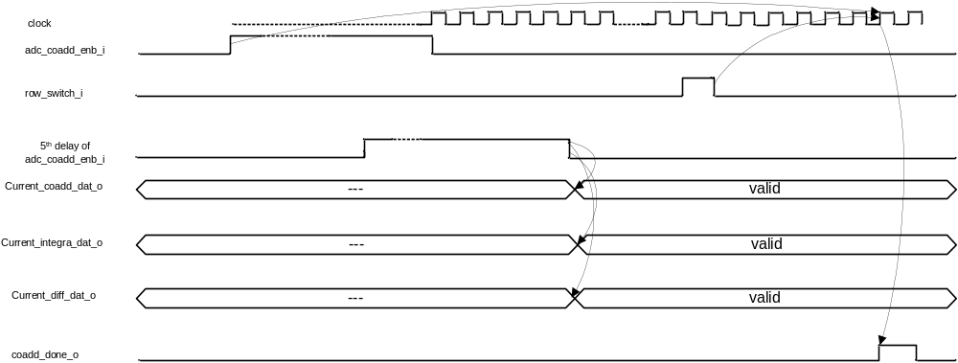
Figure 10: Dynamic Data Manager Timing Protocol.

High-Level Description

State Machine Descriptions

Raw Data Manager
The Algorithmic State Machine (ASM) for the raw data manager is shown in Figure 11.

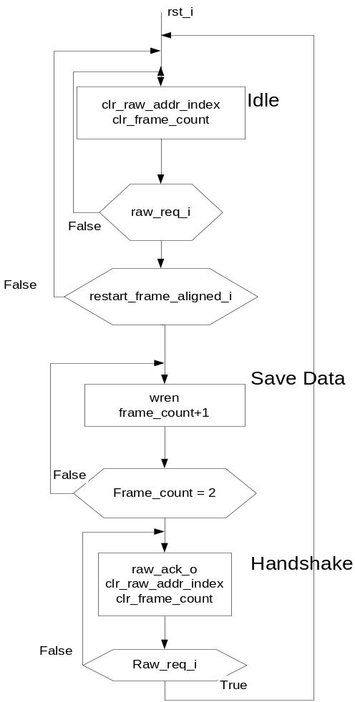
Figure 11: Raw Data Manager Algorithmic State Machine.

A timing diagram representation of the control signals for the raw data manager is shown in Figure 12.

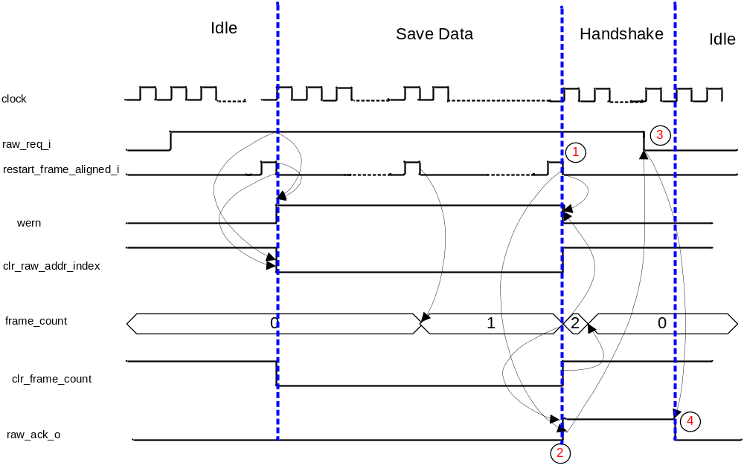
Figure 12: Raw Data Manager Control Signals Timing.

Co-add Data Manager
The ASM chart for the co-add data manager is shown in Figure 13.

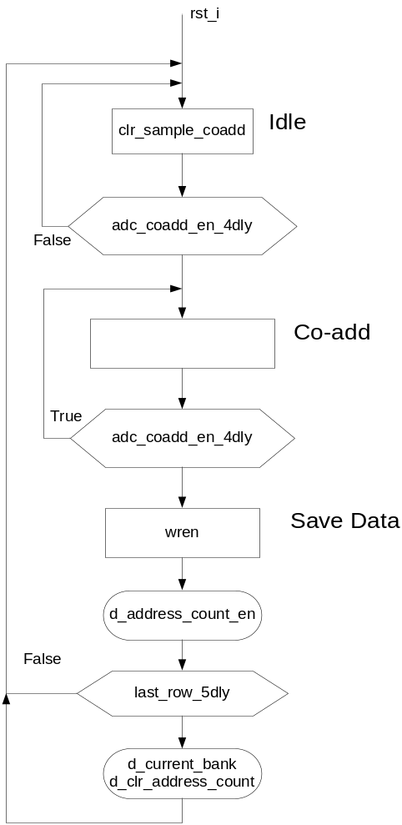
Figure 13: Co-add Data Manager Algorithmic State Machine.

In Figure 13, d_address_count_en, d_current_bank, and d_clr_address_count indicate that these signals are delayed to the next clock cycle. Moreover, current_bank is not a one-clock pulse. However, it is inverted each time it is asserted. In addition, clr_sample_coadd is used to clear the register holding the value of the co-addition. Finally, address_count_en and clr_address_count are used to enable and clear the address index counter that points to the next memory location.
A timing diagram of the required control signals are illustrated in Figure 14, where the adc_coadd_en_i in the last row is shown.
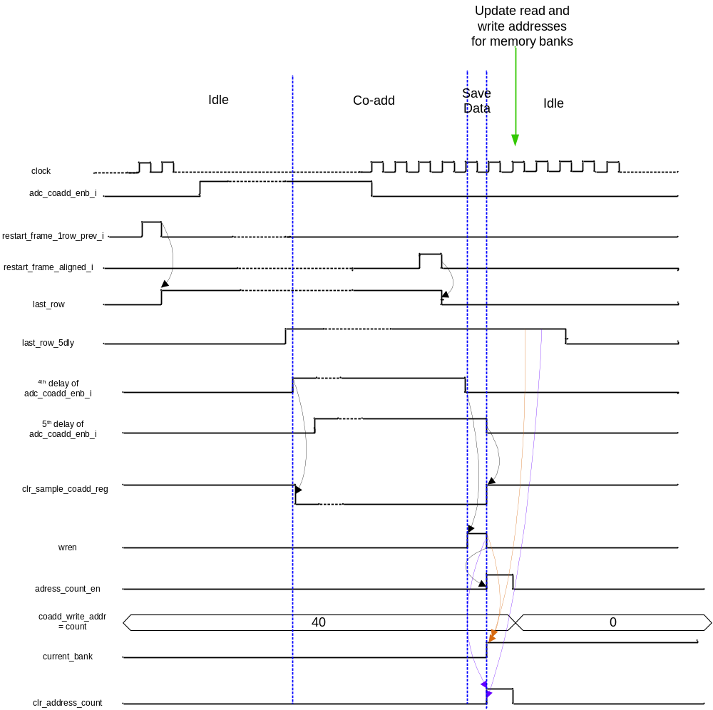
Figure 14: Co-add Data Manager Control Signals Timing.

Dynamic Data Manager
The operation of the dynamic data manager closely follows that of the co-add data manager. Therefore, the dynamic data manager saves the results of its calculation in the same time slot when the co-add data manager saves the result of the co-addition in the memory.

Special Optimizations

Files of the Block

Source Code

Source1.vhd

Header Code

Header1.vhd

Naming Conventions Used

